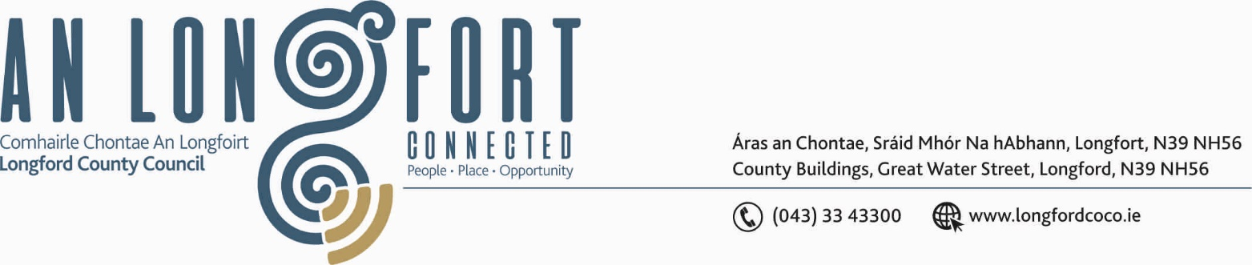
3u Iuil 2019.

Chuig: Gach Ball don Chomhairle.

A Chomhairleoir,

Iarrtar ort bheith i láthair ag Cruinniú Míosuil Chomhairle Chontae Longfoirt a tionólfar i Seomra na Comhairle, Aras an Chontae, Longfoirt ar an Chéadaoin, 10u Iuil 2019 ag 3.00 p.m. chun gnó a dhéanamh d’réir an Chláir thíos.
You are requested to attend the Monthly Meeting of Longford County Council to be held in the Council Chamber, Aras an Chontae, Great Water Street, Longford, on Wednesday, 10th July 2019 at 3.00 p.m to transact business, as set out on the Agenda hereunder.

Mise le meas,
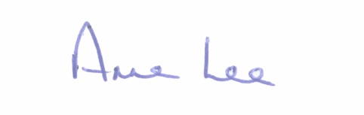

_______________
Anne Lee,
Meetings Administrator.

C L A R

Prayer before Meeting.

- Confirmation of Minutes of the following meetings of Longford County Council – enclosed.

(i) Monthly Meeting held on the 8th May 2019.
- Annual Meeting held on the 7th June 2019.

- Matters arising from Minutes.

3. Declaration of Interest by Members.

4. To note Management Report - to follow.

5. To note adopted Minutes of Corporate Policy Group Meeting held on
6th March 2019 – copy enclosed.

6. Strategic Infrastructure and Climate Change.

- To note Planning Applications received since last meeting of the Council.

- Appointment of a Chairperson and remaining member to the Local Traveller Accommodation Consultative Committee - referred from 2019 Annual Meeting.

- Consideration of disposal of Property at Robinstown, Granard, Co. Longford
to Edward Flynn, 12 Colmcille Terrace, Granard, Co. Longford in accordance with the terms of Section 183 of the Local Government Act 2001 issued on the 19th June 2019.

- Consideration of Adoption of Part 8 Report (Planning and Development Act 2000 (as amended) and Planning and Development Regulations 2001) (as amended) in respect of Retention and Completion of 25 No. Dwelling Houses and associated works at Carragh, Granard, Co. Longford - details attached.

- Consideration of Adoption of Part 8 Report (Planning and Development Act 2000 (as amended) and Planning and Development Regulations 2001) (as amended) in respect of construction and upgrade of c.1km path linking Keenagh with Mosstown Harbour and Royal Canal at Keenagh, Co. Longford - details attached.

- Consideration of Adoption of Part 8 Report (Planning and Development Act 2000 (as amended) and Planning and Development Regulations 2001) (as amended) in respect of construction of an Amenity Walkway through part of the Bord na Mona Cutaway Bog at Corlea Trackway Centre, Keenagh, Co. Longford - details attached.

- Consideration of Adoption of Part 8 Report (Planning and Development Act 2000 (as amended) and Planning and Development Regulations 2001) (as amended) in respect of construction of Traffic Calming on the Newcastle Road, Ballymahon, Co. Longford -
details attached.

- Notice of Motion submitted by Councillor Gerard Farrell .
“That a Climate Action Committee be established on Longford County Council.”

7. Community and Enterprise.

- Consideration and adoption of 2018 Annual Report - enclosed.

- Longford County Council Corporate Plan 2019 – 2024.

- Review of Standing Orders - draft enclosed

- Local Elections (Disclosure of Donations & Expenditure)- Submission of Expenditure
Statements.

- Approval to the following appointments – as agreed at Municipal District Annual Meetings –
Longford Pool Construction Ltd.
Councillors Gerry Hagan, Gerry Warnock and
Martin Monaghan.
Longford Enterprise Development Company Ltd -
Councillors Seamus Butler, Joe Flaherty, Mick Cahill and Micheal Carrigy
Regeneration Committee.
Cathaoirleach of Longford County Council
Councillors Gerry Warnock, John Browne, Joe Flaherty,
Gerard Farrell, Paul Ross, Mick Cahill, P.J. Reilly,
Turlough McGovern and Paraic Brady.
Creative Ireland Culture Team.
Councillors Martin Monaghan, Pat O’Toole and Paraic Brady

County Longford Heritage Forum.
Councillors Peggy Nolan, Paul Ross and Turlough McGovern.
County Longford Tourism Committee.
Councillors Joe Flaherty, Gerard Farrell and Garry Murtagh.

8. Finance & Support Services.

- Issue and acknowledgement of the following Local Authority Members’ Policy Documents
- to follow.

- Code of Conduct for Councillors.
- Communications Policy.
- Social Media Policy.
- Dignity at Work Policy and Procedures.
- Data Protection Policy.
- Guidelines for the Safeguarding of Children.
- Health and Safety Statement.
- Acceptable Use Policy.

- Establishment of Audit Committee.

9. General

- Correspondence - copies enclosed.

- Correspondence dated 21st May 2019 received from the Minister for Transport, Tourism and Sport regarding the Road Traffic (Amendment) Act 2019.
- Correspondence received from Kevin Bell acknowledging the Council’s donation to The Kevin Bell Repatriation Trust.
- Correspondence dated 21st June 2019 received from The Minister for Finance and Public Expenditure regarding the Sugar Sweetened Drinks Tax.

- Notice of Motion submitted by Councillor Colm Murray.

“Longford County Council calls on the Dept. of Agriculture, The Irish Greyhound Board and The Irish Coursing Club to take whatever action necessary following the recent RTÉ Investigates documentary to ensure the greyhound industry in Ireland puts the welfare of the animal to the forefront of their objectives and future planning”

Notice of Motion submitted by the Eighteen Members of Longford County Council.

“That Longford County Council calls on the Department of Employment Affairs and Social Protection to restore the 'Tools and Materials Budget' for CE schemes from €12 to €20.”

10. Training -
Consideration of Report from Corporate Policy Group.

11. Votes of sympathy.



